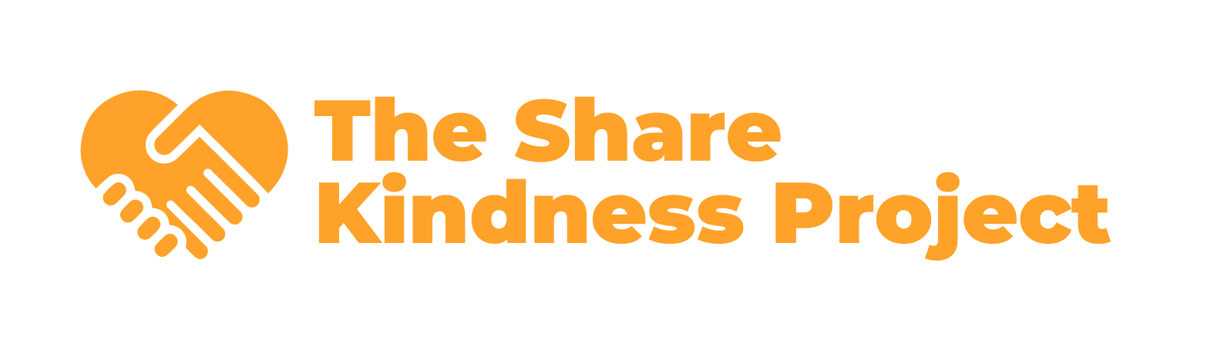

Purpose
Volunteers are essential to achieving The Share Kindness Project’s mission of creating a kinder world by providing free resources and hosting community events. This policy outlines the expectations, rights, and responsibilities of volunteers to ensure a positive, safe, and productive environment for everyone involved.

1. Volunteer Code of Conduct
Volunteers of The Share Kindness Project are expected to:
- Uphold the mission and values of the organization.
- Treat all individuals with respect, kindness, and fairness.
- Maintain confidentiality of sensitive information.
- Act responsibly, ethically, and with integrity at all times.
- Refrain from any behavior that could harm others or the organization’s reputation.

2. Volunteer Eligibility
- Age Requirements: Volunteers must be at least 14 years old. Minors (under 18) must have parental or guardian consent.
- Skills and Qualifications: Volunteers must possess the necessary skills for their roles. Training will be provided as needed.
- Background Checks: Certain roles involving vulnerable populations or financial responsibilities may require background checks.

3. Volunteer Rights
Volunteers have the right to:
- A welcoming, safe, and inclusive environment.
- Clear expectations, training, and support for their roles.
- Reimbursement for pre-approved out-of-pocket expenses, where applicable.
- Recognition for their contributions to the organization.

4. Volunteer Responsibilities
Volunteers are responsible for:
- Arriving on time and fulfilling their agreed-upon commitments.
- Informing their supervisor promptly if they are unable to attend or complete a task.
- Following organizational policies and procedures.
- Representing The Share Kindness Project positively to the community.

5. Volunteer Roles
The Share Kindness Project offers a variety of volunteer opportunities, including but not limited to:
- Event setup and teardown.
- Distributing resources and information to the community.
- Administrative support.
- Social media and content creation.
- Assisting with workshops or activities.

6. Training and Supervision
- Orientation and Training: New volunteers will receive an orientation to understand the organization’s mission, policies, and their role. Role-specific training will be provided as necessary.
- Supervision: Volunteers will report to a designated staff member or experienced volunteer for guidance and feedback.

7. Safety and Liability
- Workplace Safety: Volunteers are expected to adhere to safety protocols and report hazards or incidents immediately.

8. Confidentiality
Volunteers must maintain confidentiality of any sensitive information they encounter, including donor information, personal details, or organizational strategies.

9. Volunteer Dismissal
The Share Kindness Project reserves the right to dismiss volunteers who:
- Fail to adhere to policies or procedures.
- Engage in misconduct or behavior that endangers others or the organization’s reputation.
- Repeatedly fail to meet agreed-upon commitments without valid reason.

10. Recognition and Appreciation
The Share Kindness Project values its volunteers and will recognize their contributions through thank-you events, certificates, and other forms of acknowledgment.

11. Policy Review
This policy will be reviewed annually by the Board of Directors to ensure it reflects current best practices and meets the organization’s needs.

Adopted by the Board of Directors on 12/09/2024
Hayden Hahn
Hayden Hahn | Project Director

