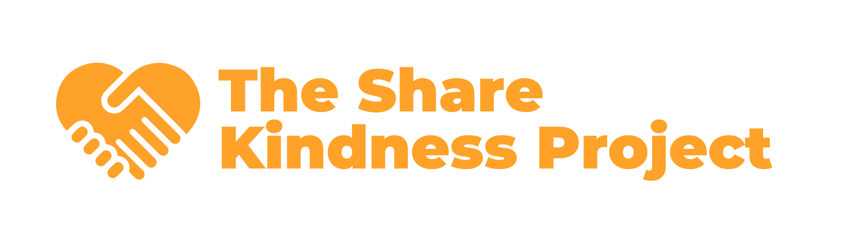

Purpose
The Share Kindness Project is committed to creating a kinder world through free resources and community events. This Gift Acceptance Policy ensures all contributions align with our mission, comply with applicable laws, and maintain the integrity of the organization.

Scope
This policy applies to all gifts received by The Share Kindness Project, including monetary contributions, in-kind donations, real property, securities, and other assets.

1. General Policy
- Mission Alignment: All gifts must support The Share Kindness Project's mission and values.
- Legal Compliance: Gifts must comply with all applicable laws and regulations.
- Unrestricted vs. Restricted Gifts:
  - Unrestricted Gifts: Preferred, as they allow flexibility to allocate funds where needed most.
  - Restricted Gifts: Accepted if the donor's intent aligns with our mission and programs. Restrictions must be documented in writing.

2. Types of Acceptable Gifts
The Share Kindness Project may accept the following types of gifts:
- Cash: Cash, checks, or electronic transfers.
- In-Kind Donations: Goods or services directly benefiting our programs.

3. Review and Approval Process
- Automatic Acceptance:
  - Unrestricted cash or publicly traded securities valued under $10,000.
- Review Required:
  - Gifts with conditions, restrictions, or significant value ($10,000+).
  - Non-standard assets such as real estate, closely held securities, or items requiring special handling.
  - These gifts must be reviewed and approved by the Board of Directors or its designated committee.

4. Declining a Gift
The Share Kindness Project reserves the right to decline gifts that:
- Are inconsistent with our mission or values.
- Create financial, legal, or reputational risks.
- Require services or actions outside our capabilities.

5. Donor Recognition and Privacy
- Acknowledgment: All donors will receive written acknowledgment in compliance with IRS requirements.
- Recognition: Donors may be recognized publicly unless they request anonymity.
- Privacy: Donor information will not be shared or sold.

6. Policy Review
This policy will be reviewed annually by the Board of Directors to ensure it remains relevant and effective.

Adopted by the Board of Directors on 12/09/2024
Hayden Hahn
Hayden Hahn | Project Director

